Reading 4

Bart Quaink - 11121424

Interactive map 1 : Bing Maps

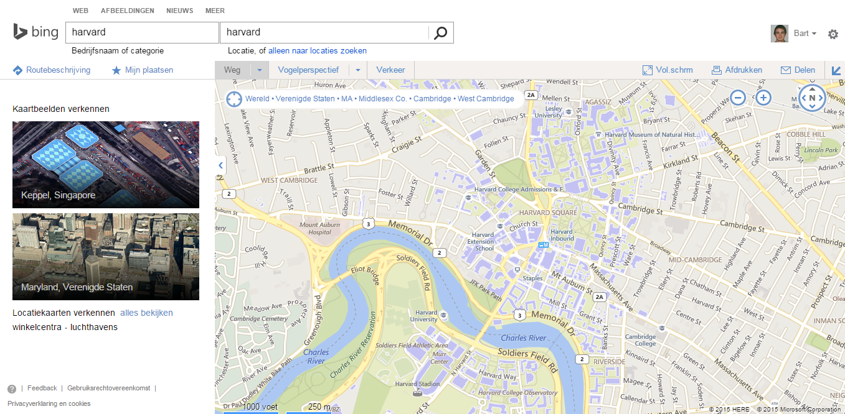

Interactive map 2 : Google Maps

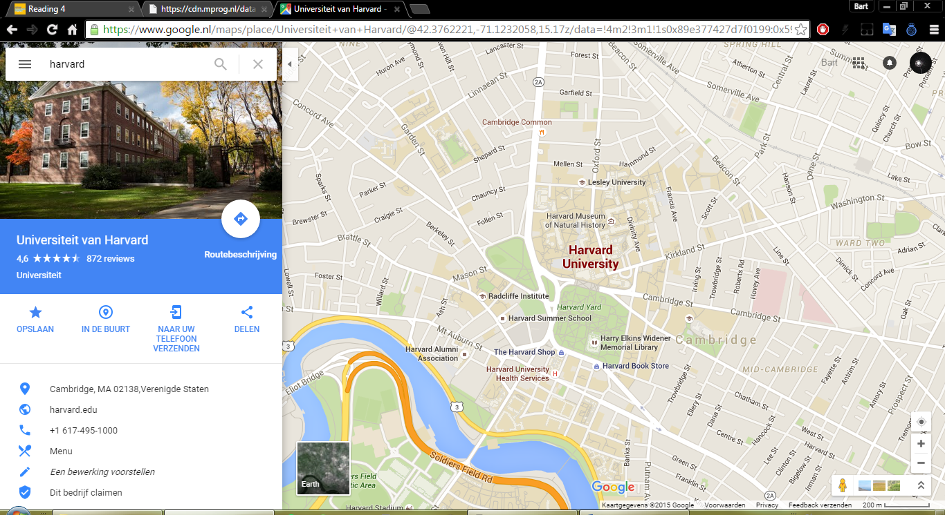

1. Bing maps gives a clearer visualization regarding a quick overview of the buildings that are part of Harvard University. By giving the buildings that are part of Harvard a blue colour, it’s easy to recognize that they belong together. Easily combining this feature, colour, and obviously shape as well, is called *binding*. Google maps is using binding as well, but not as well as Bing maps. Blue on a whitish/grey background works better than light red on a grey background. The border of the buildings are also thicker in Bing maps, which also helps spotting the buildings. Due to quickly setting a pattern in your brain for the buildings of Harvard on Bing maps, we tend to look for the same pattern more often.

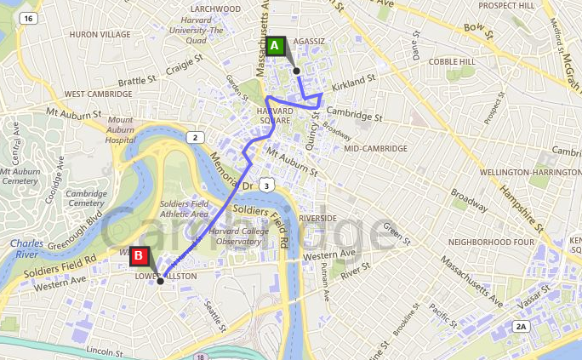Bing maps, from Harvard museum of natural history to Harvard stadium.

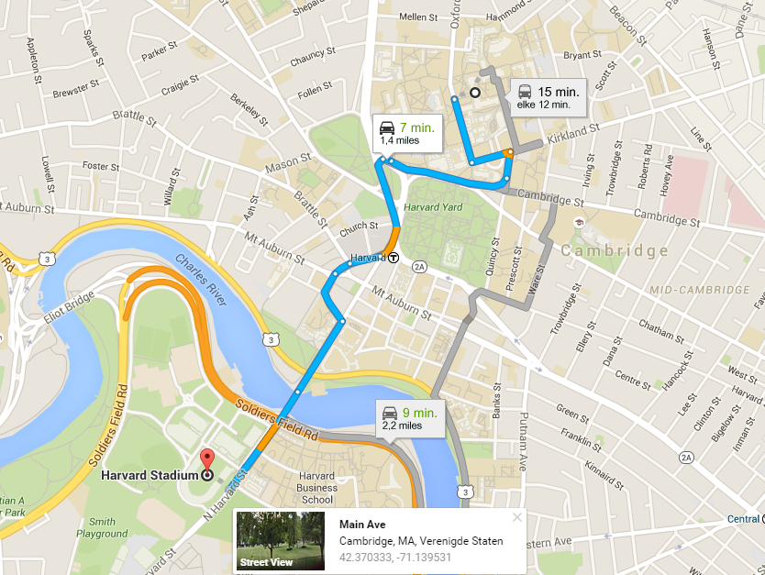Google maps, from Harvard museum of natural history to Harvard stadium.

1. Choosing the better visualization between these two was quite the task for me. Bing maps obviously has the better contrast between the planned route and the background. This makes the different pattern-factors a bit better distinguishable comparing to Google maps. The line is smoother, colour is better and the notification of where the start- and endpoint is is better shown in Bing maps. When disregarding the horrible search function on Bing maps (searching for Harvard stadium for example was not possible) Google maps has the better overall interface. Due to the clearer and better looking overall map it’s easier to recognize top-down patterns in recognizable parts near the area. This makes it easier to set yourself in the idea of actually walking/biking the planned route.
2. Overall it’s hard to say which one has the better visualization. There are some interactivity issues with Bing maps that didn’t work as well as with Google maps. The overall view of an area is better and clearer with Google maps. If you want to search for a specific area, building or ground Bing maps takes this round, the visualization method of Bing shows the desired buildings clearer and better than Google maps. Google maps makes it more colourful, interactive, easy to look at and understand, which is also a vital part in creating a good visualization. I wouldn’t say one is better than the other, because the way they were created obviously shows during creating of the two the creators had different mind-sets in how they wanted the visualization to look like and what the intended goal is with the visualization. But if you’d ask me to look up, say which two rivers create the delta in Bangladesh, I’d go directly to Google maps.

Map of populations in Europe, using rainbow colour scheme

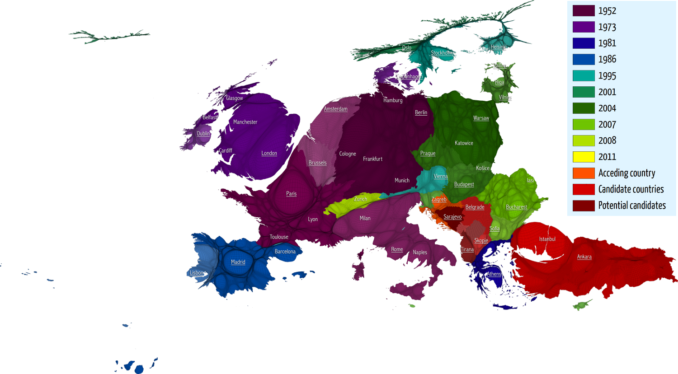

1. Visualization source: “The social atlas of Europe” <http://www.policypress.co.uk/display.asp?K=9781447313533>

The goal of the atlas is to “map Europe according to these realities, from the perspective of human geography rather than simply a political one”. By using full colour-visualization methods, the author wants people to reconsider European identity through all of its different facets. By using a rainbow colour scheme the author thinks the visualization of Europe goes in a more fluent way than ever done before. By using new visualizations and colour schemes not often used, the user should get a new perspective on a range of topics. It’s a bold move remapping and visualizing Europe in such a way, and frankly, after looking at the picture, I don’t think it’s doing such a great job at it. By choosing a different colours scheme, a rainbow one, than normally used by visualizing these types of maps the author wants us to gain a new perspective. While for me it’s just a unordered colour scheme. I have no idea what the colours mean in first glance and there is not a logical flow in the scheme at all. I get that each colour is supposed to be linked to a different value, whether if it’s a year or countries wanting to get into the EU (also a guess, the visualization gives no info about the three red colours). Then again, what’s the point of creating a map, reorganizing the borders of the countries to relative population size and then mapping the colours in which year they were officially considered part of the EU? And what do all the random circles in the countries mean? Obviously, this is taken from an atlas, and out of context and without the actual explanation of the atlas it’s going to be a lot harder to actually know what’s going on in the picture. But still, a visualization on it’s on has to be at least a bit self-describing to know what’s going on in the picture. So there is a reason the author has used this colour scheme in this visualization, but I don’t think it was reason enough to actually use it.

1. First of all, don’t put different values in one colour scheme. The idea is ok that even though a lot of countries want to be part of the EU can be considered future members, so it can be possible to put them in one colour scheme. But I just wouldn’t. Separate the list in members of the EU, and possible members. This way it’s easier to see which ones are part of the EU and which ones are not. Then I would really think about what I actually want the reader to see. Is it really necessary to organize them in year of joining the EU? Why not with all these years show the years they joined somewhere different and just colour them as part of the EU or not. If that still isn’t possible, I would cut the list into 4 parts, original members, and then a timeframe in three parts. This way you can easily show which members were the original EU members, and which ones joined in what time period. Then, because the map already shows the capitals and some larger cities, just show on the map what specific year they became a member. On this way, it’s an easy overview of which country belongs to the EU, when they became part of it, and which countries are good candidates of joining the EU, all while not losing the actual intended goal of the map, to show the population relative to country size.